**Aim**: Configure the router to secure the port and Telnet from unauthorized users. Analyze enable secret and password login commands in detail.

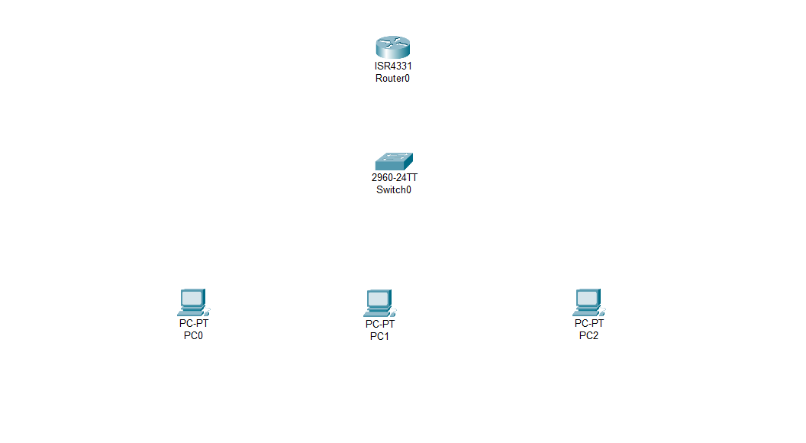**Step – 1:-** Open the Cisco Packet tracer and take one Router , one Switch and 3 PC.

**Step – 2 :-**  Now Connect the Router and Switch into the Giga Ethernet Port and all the PC’s into Fast Ethernet Port using Cross Over Cable.

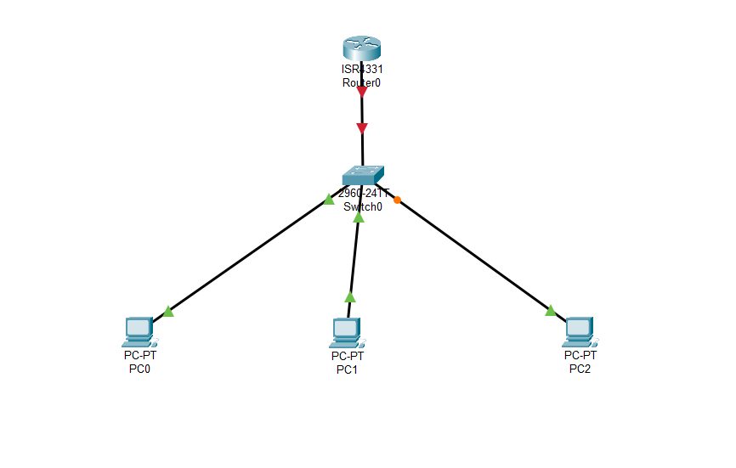

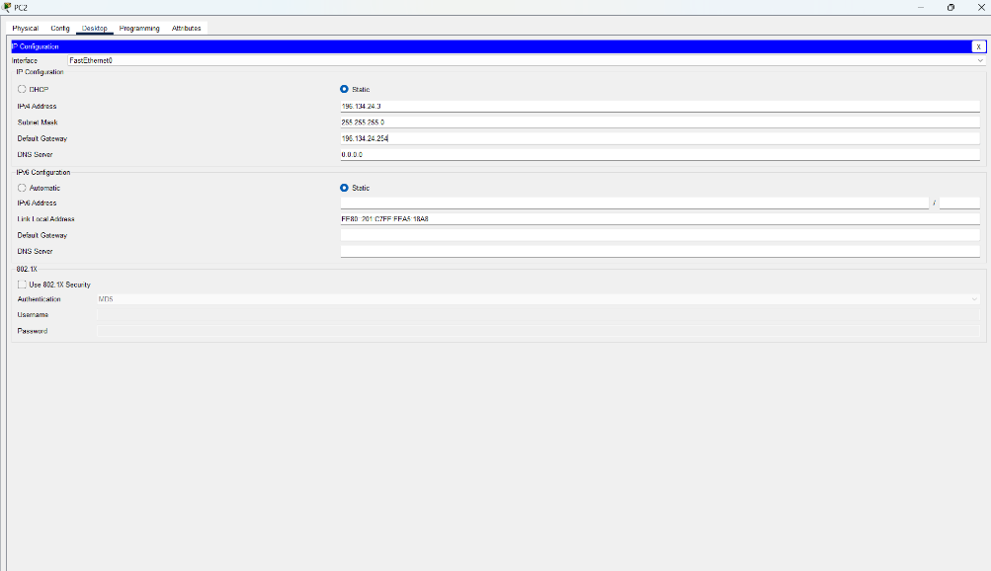**Step – 3 :-**  Now Assign the PC’s with IP Address , Subnet Mask and Default gateway.

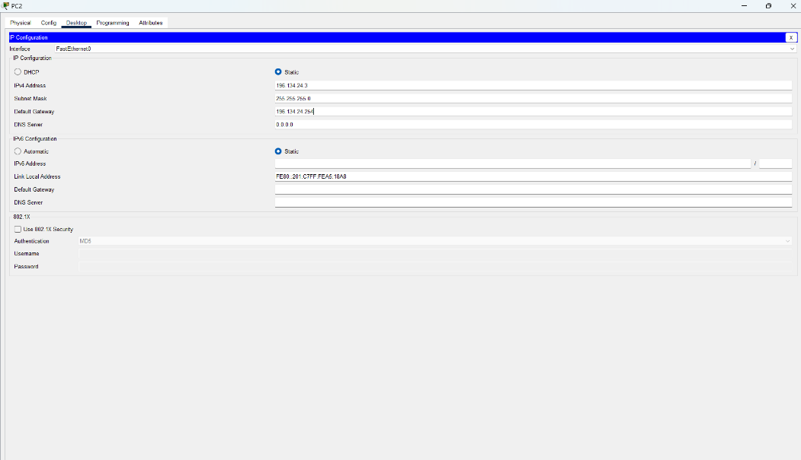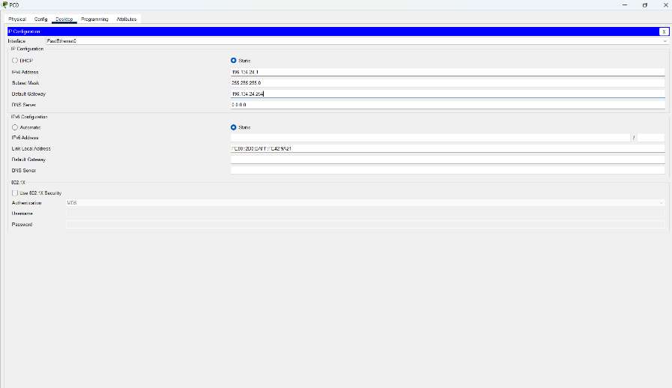

**Step – 4 :-**  Now we will configure the router. To configure the router we have to use the console cable with the console port but in Cisco Packet Tracer we can do it directly using the router’s CLI.

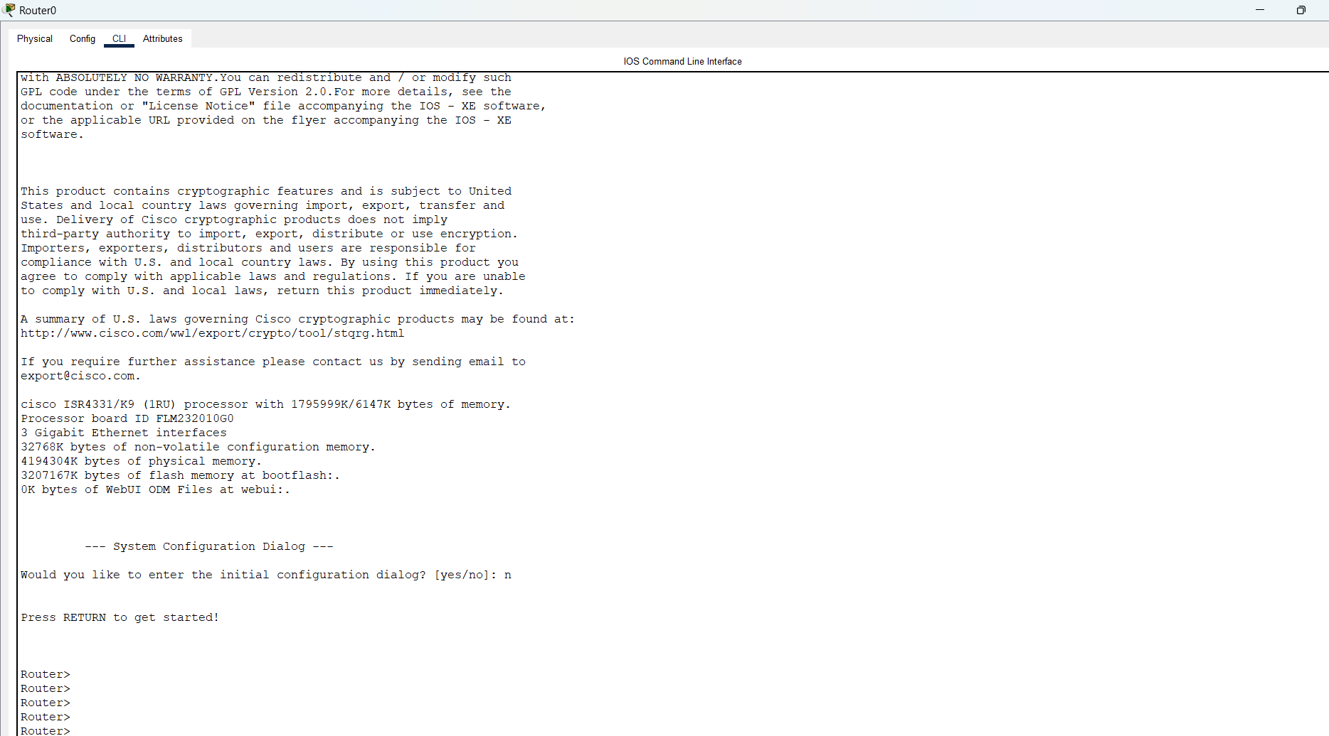

**Step – 5 :-**  Now enter the command “enable” to enter into privilege mode.

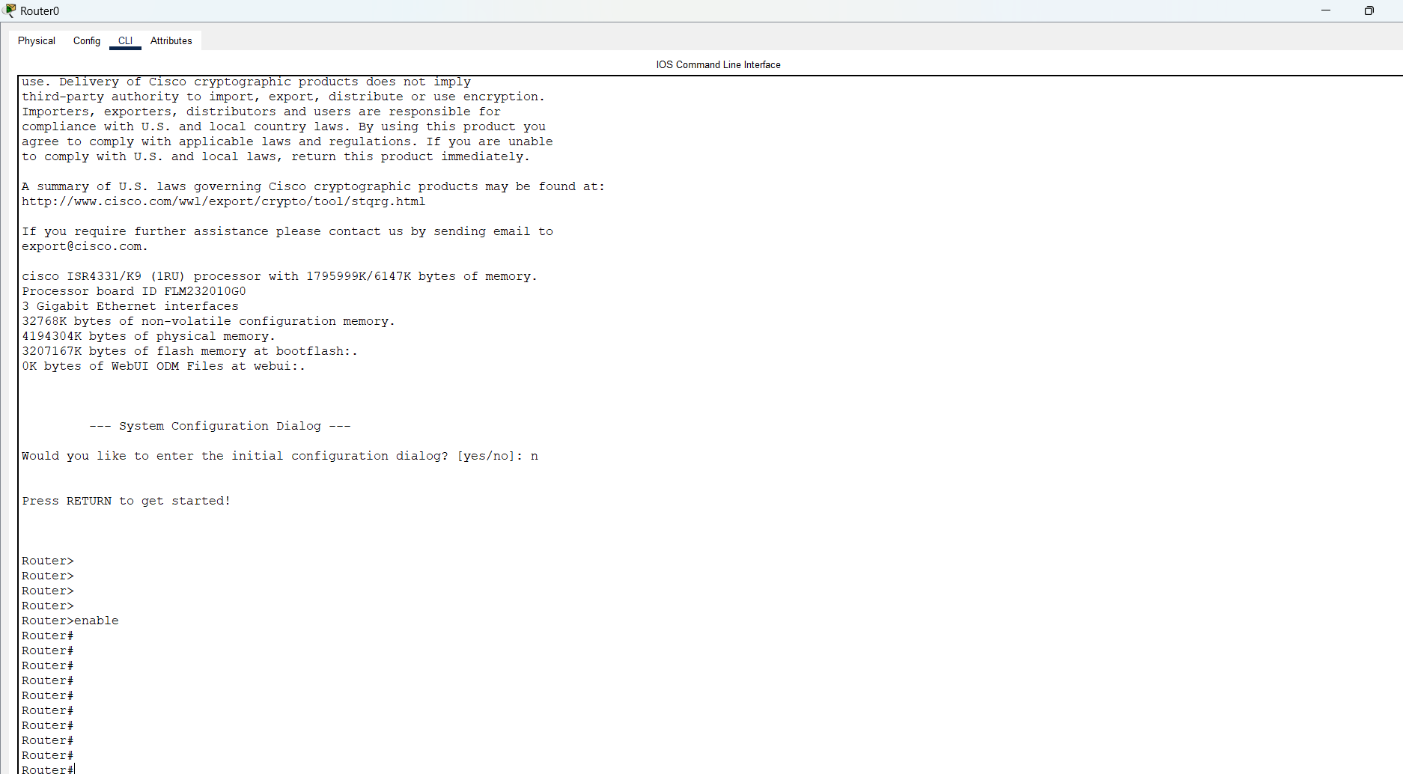

**Step – 6:-**  Now enter the command “config t” to enter into configuration mode.

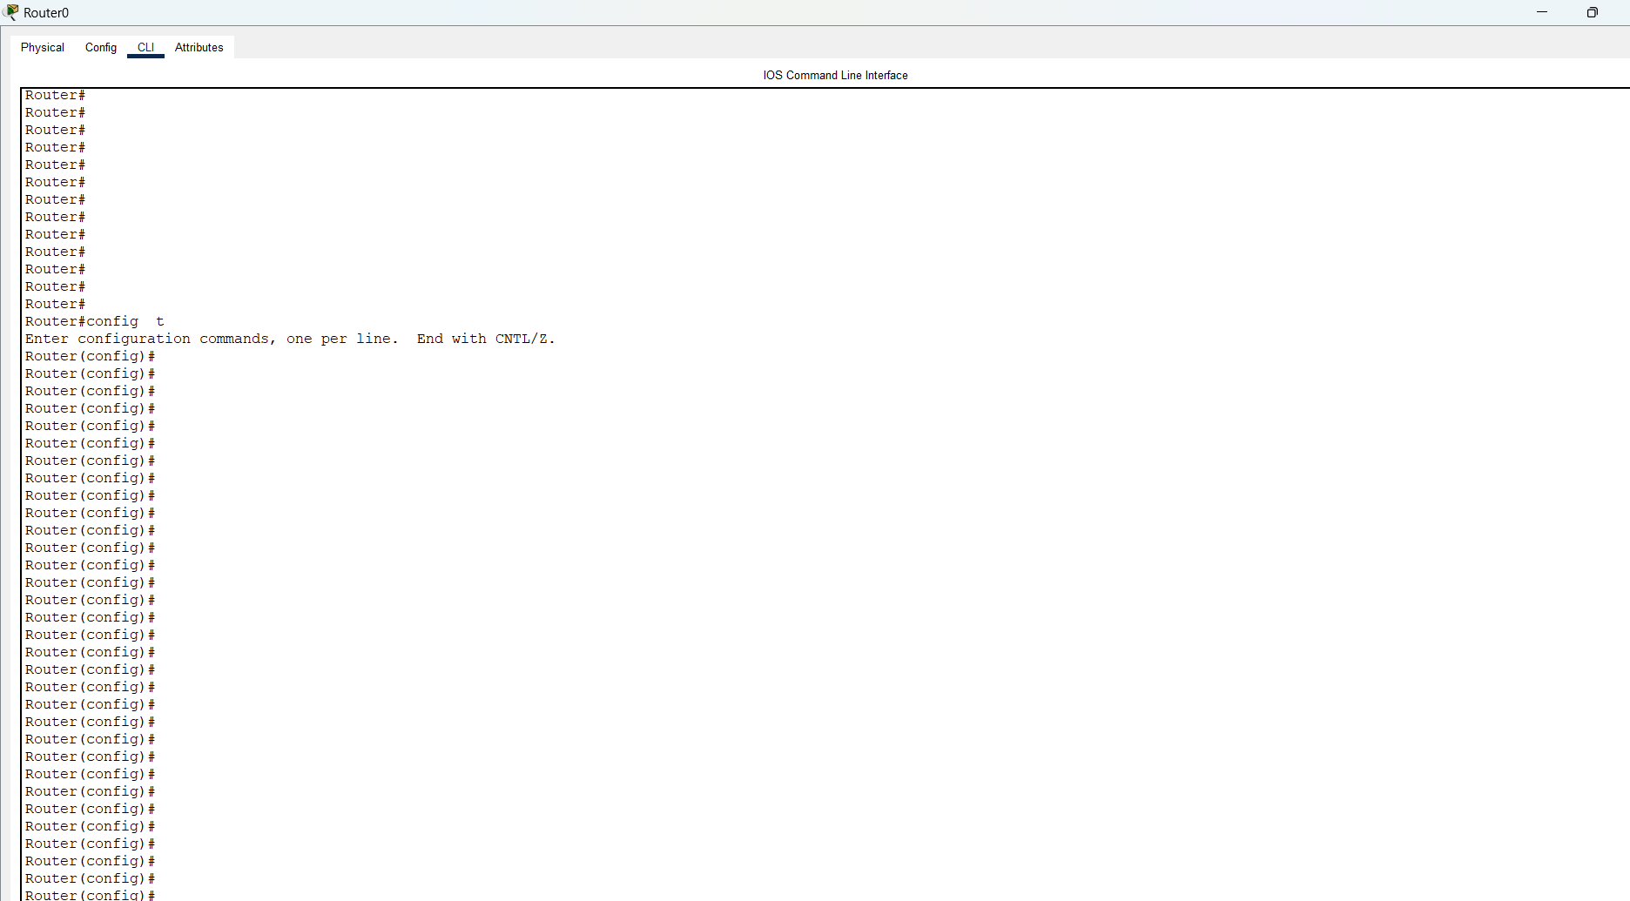

**Step – 7 :-**  Now Change the Hostname Using the command “**hostname host_name**”.

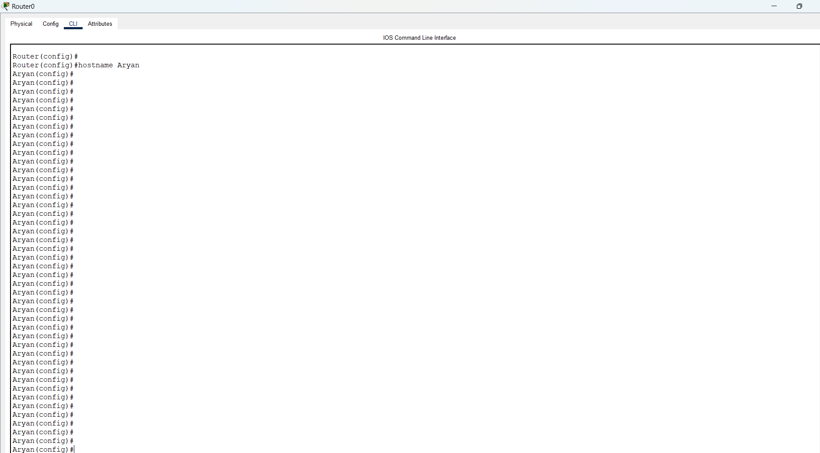

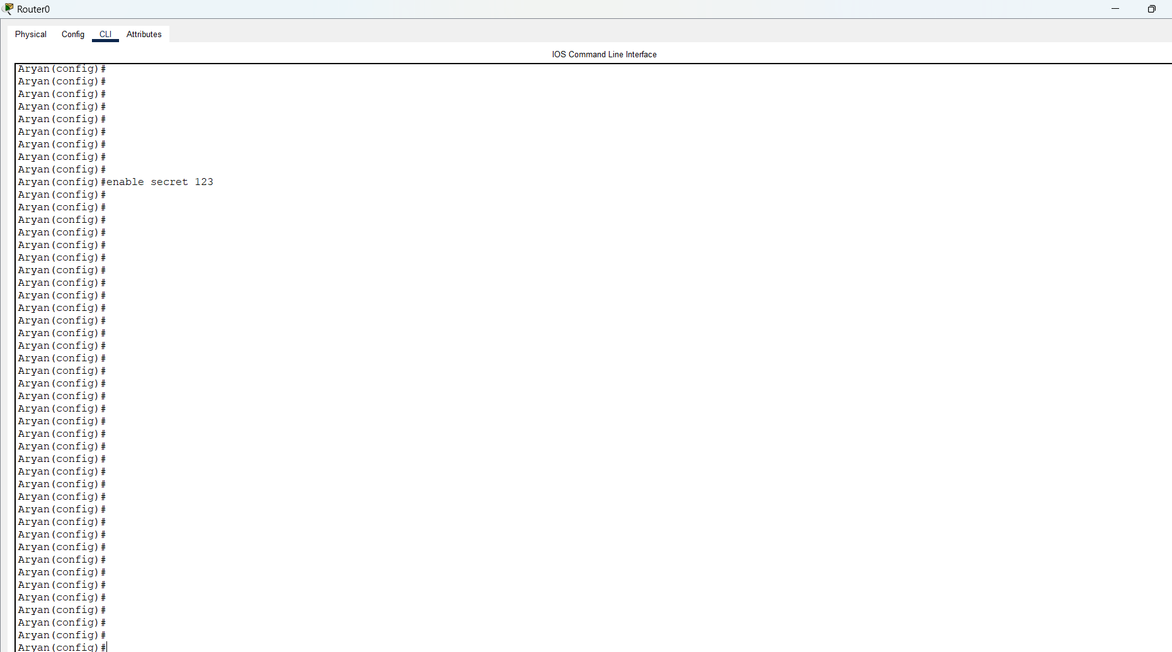**Step – 8 :-**  Now Set the Password using “**enable secret pswd**” to enter into privilege mode.

**Step – 9 :-**  now we will configure our router using interface command and assign the ip to the router port.

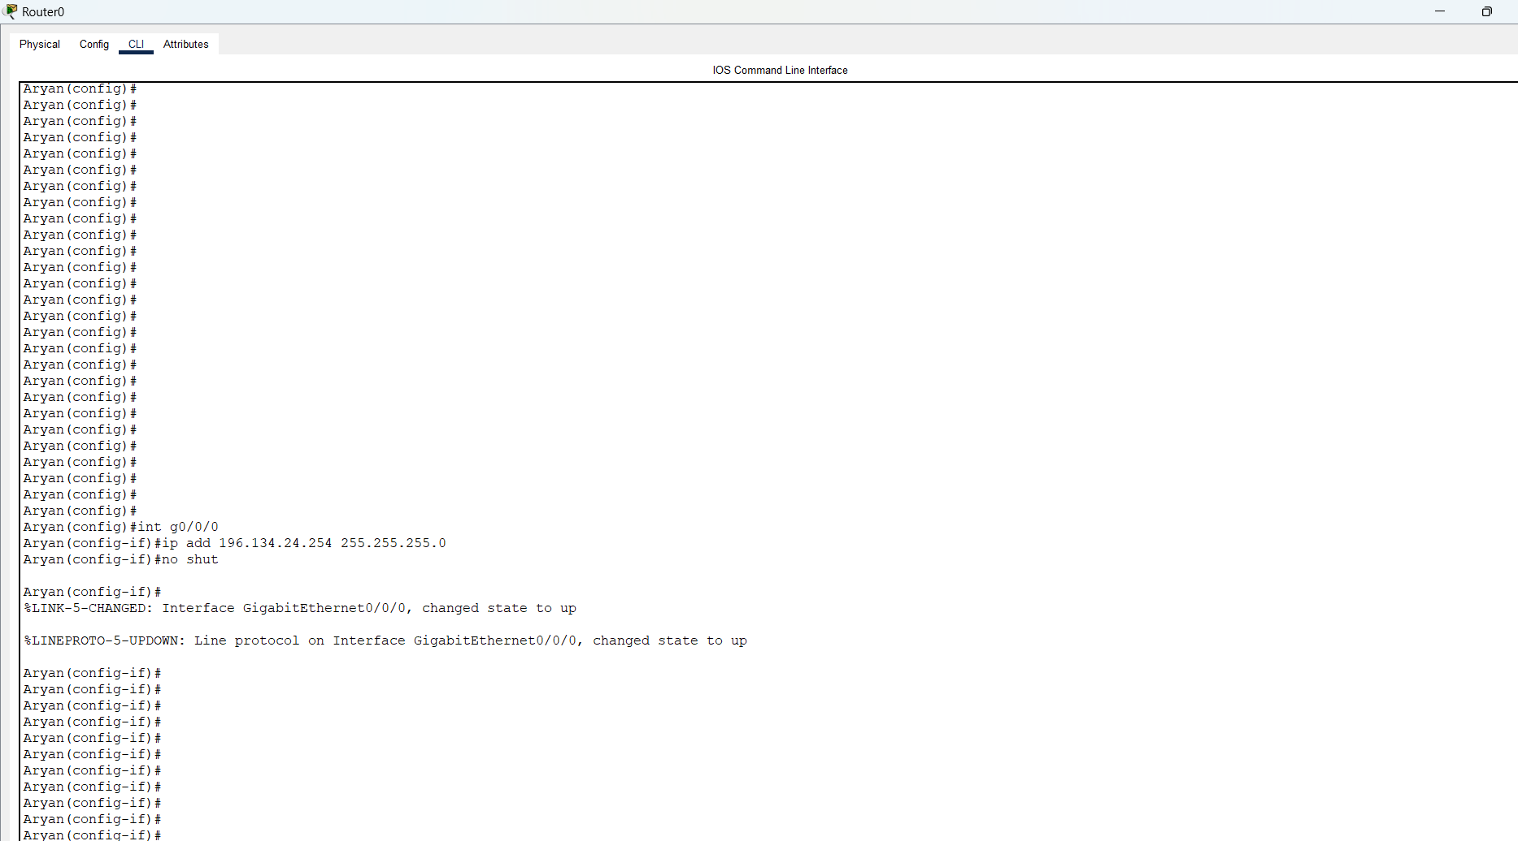

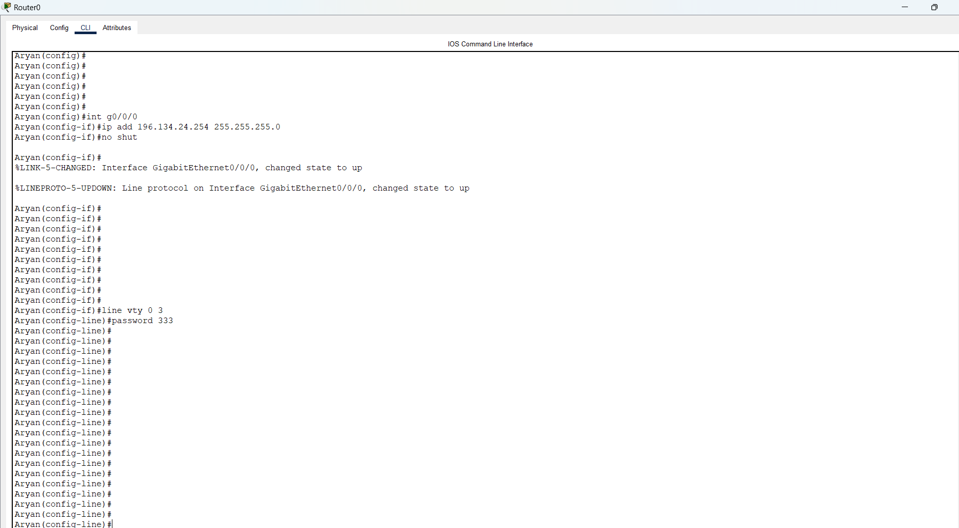**Step – 10 :-**  now we will secure the virtual line using line vty command.

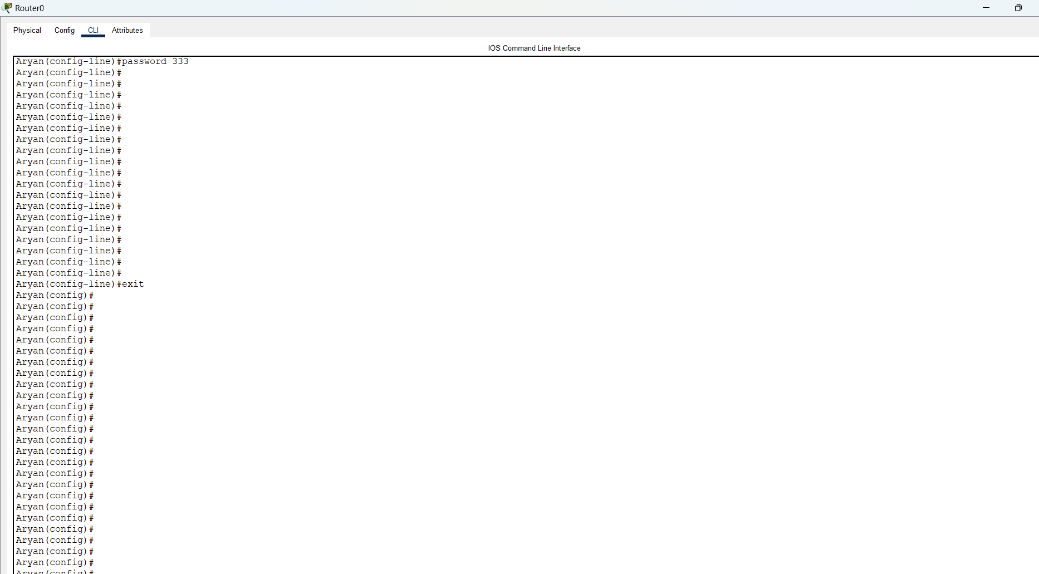**Step – 11 :-**  Now we will exit from router configuration mode.

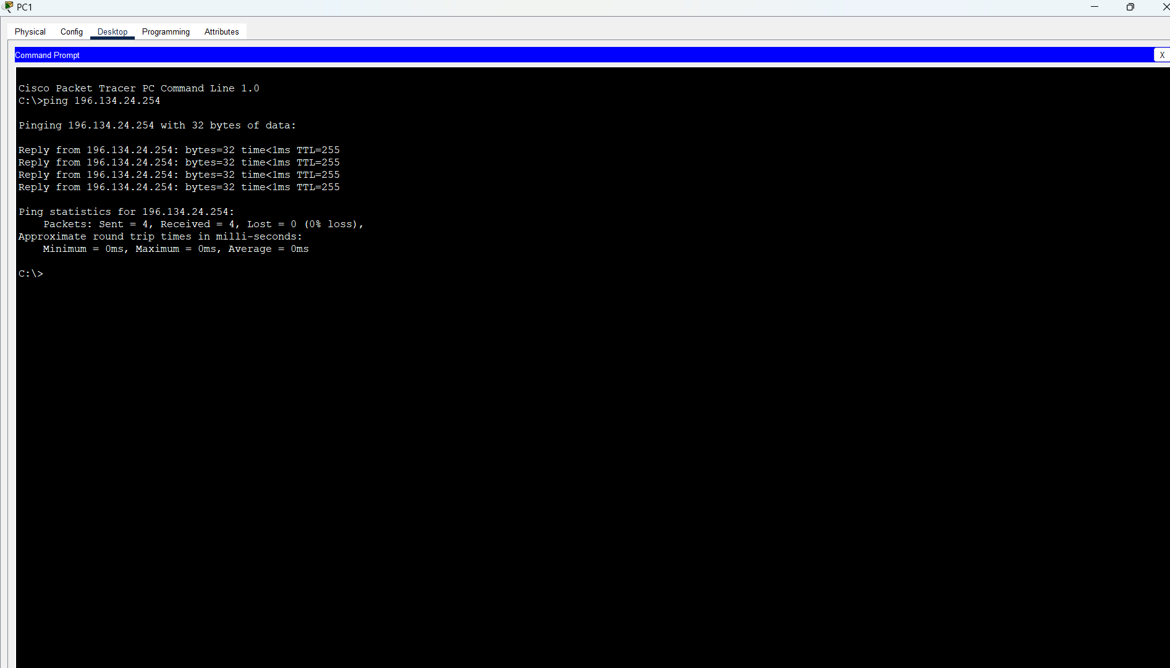**Step – 12 :-**  now open the command prompt of any PC and use ping command to check the connectivity.

We are getting appropriate reply means the connection is successfully established.

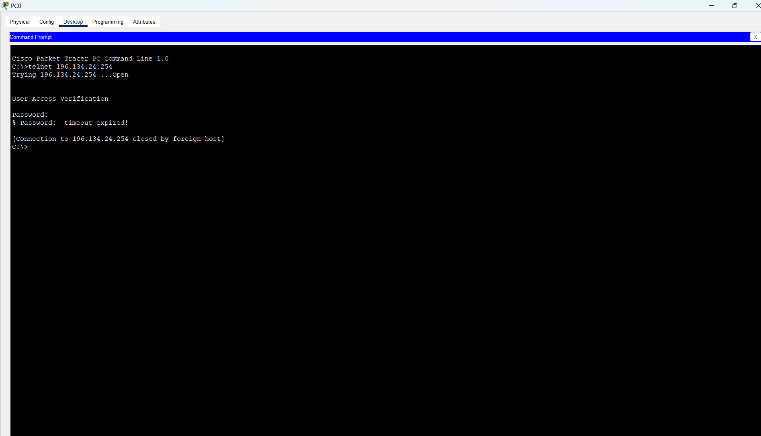**Step – 13 :-**  now we will connect to a router using telnet command

**Step – 14 :-**  now when you enter the correct password and hit enter it can allow you to access the router. Then if you wish to enter in privilege mode then it will again ask for the password we had set in enable secret. If you entered it correctly. then it will allow you to enter in privilege mode.

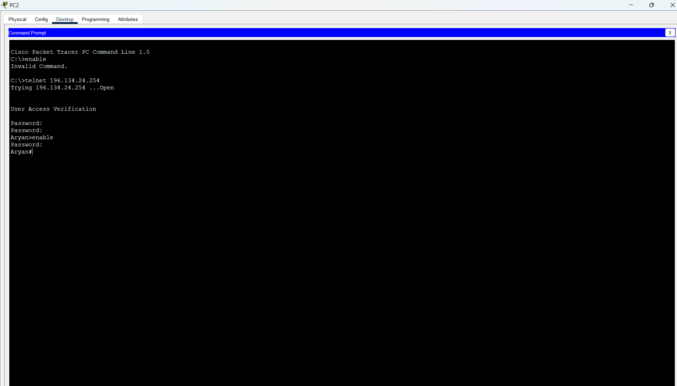

**Conclusion :-**

By Performing this experiment, we learned how to configure the router, learned about talent, learned new commands like line vty, int and configure the port. Learned about no shut which activates the port of the router.learnt about how to assign a IP address to any port of router.